DEVON HISTORIC CHURCH’S
OPEN DAY AT ST MICHAEL’S 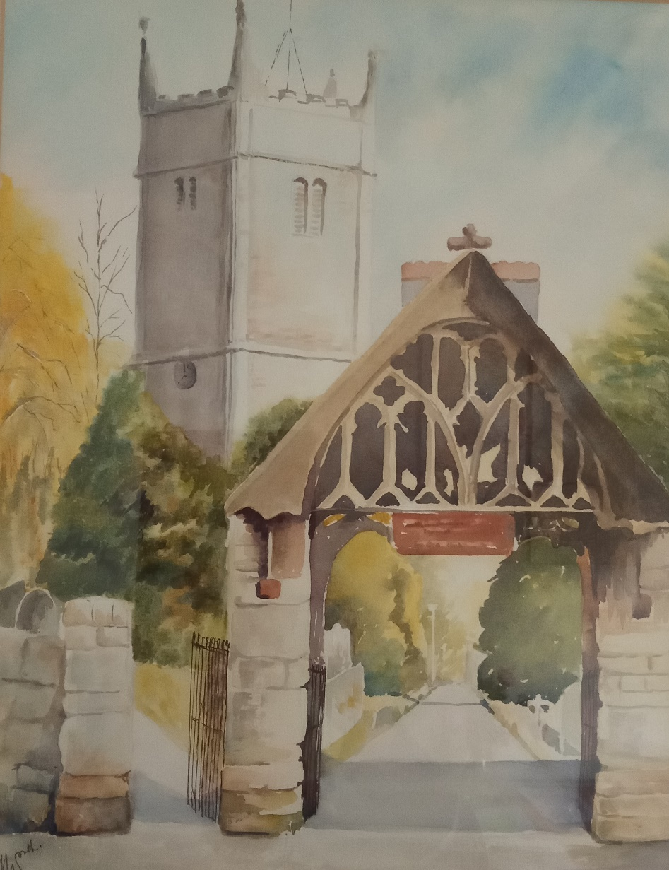
Saturday 9th September
Tower climbs 2pm – 5pm (last climb 4.30pm) Book your preferred time by contacting Ian Avery on 07966 700423 - ianwavery@gmail.com Tea/coffee & biscuits available plus display of Church magazines covering the past 75 years.

